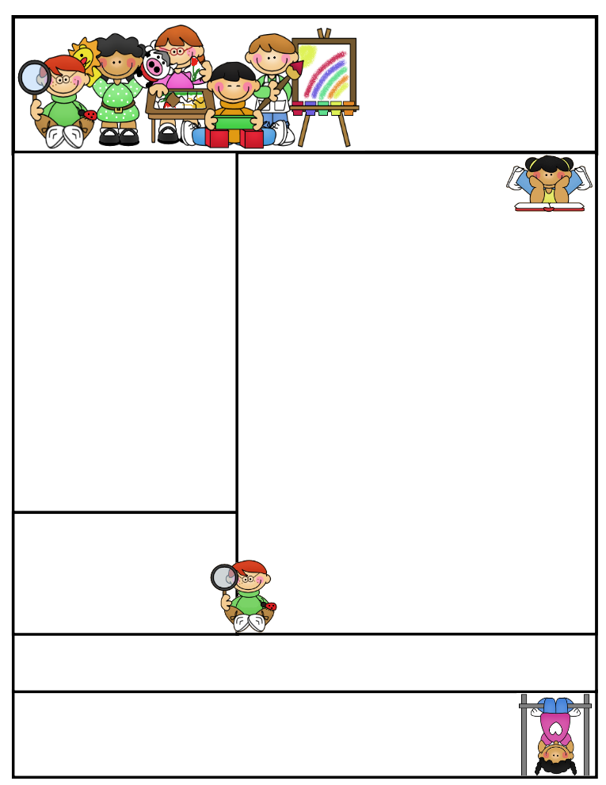

2nd grade Newsletter

April 13, 2015

[www.cherrycreek2ndgrade.weebly.com](http://www.cherrycreek2ndgrade.weebly.com)

**Literacy Tip:** Have your child verbally respond to you using complete sentences –this builds their oral language. If a child can respond in a complete sentence they can write a complete sentence. **Math Tip:** A site for printing your own addition math flashcard to practice every night- <http://www.apples4theteacher.com/math/addition/flashcards/>

**Spelling words**: took, books, foot, hoof, cook, nook, hood, wood, stood, shook, crook, cookbooks **Review:** look, good **Challenge:** crooked, bookcase

**High Frequency Words**: where, outside, maybe, called, tomorrow

**Leader in Me:**

Habit #1

Be Proactive – Choose your own weather (attitude)

**Important Dates**

**April 13-May 15—**Testing window. Make sure your child comes rested and has a good breakfast. We will hav emore specific dates for 2nd grade later.

**Friday April 17—**Croc Walk Carnival 6:30-8 p.m.

**Thursday April 23—**Leader in Me Parent Information Night.

**Dance Festival—**Wednesday May 20 1:15 p.m.

What We’re Learning

**Reading:** We will be reading and discussing a biography and discussing characteristics of non-fiction.

**Math:** We will be learning about measurement, both common and metric.

**Writing:** We will continue to review opinion writing before the end of year test.

**Social Studies/Science:** We will be studying dinosaurs.

**Grammar:** We will review adverbs.

**Spelling:** Words with oo as in book.

[**http://www.spellingcity.com/cherrycreek2ndgrade**](http://www.spellingcity.com/cherrycreek2ndgrade)

**Homework:** Read 20 minutes at least 5 days a week. **Record minutes on** [**www.rtsutah.com**](http://www.rtsutah.com)*Practice your spelling words every night.* Practice your math facts 5 minutes a night. *Fluency practice every night.* Complete the three ½ sheets*.*

*All homework should be turned in on Friday*.

**Quote for the month:**

Example isn’t another way to teach, it is the only way to teach. Albert Einstein