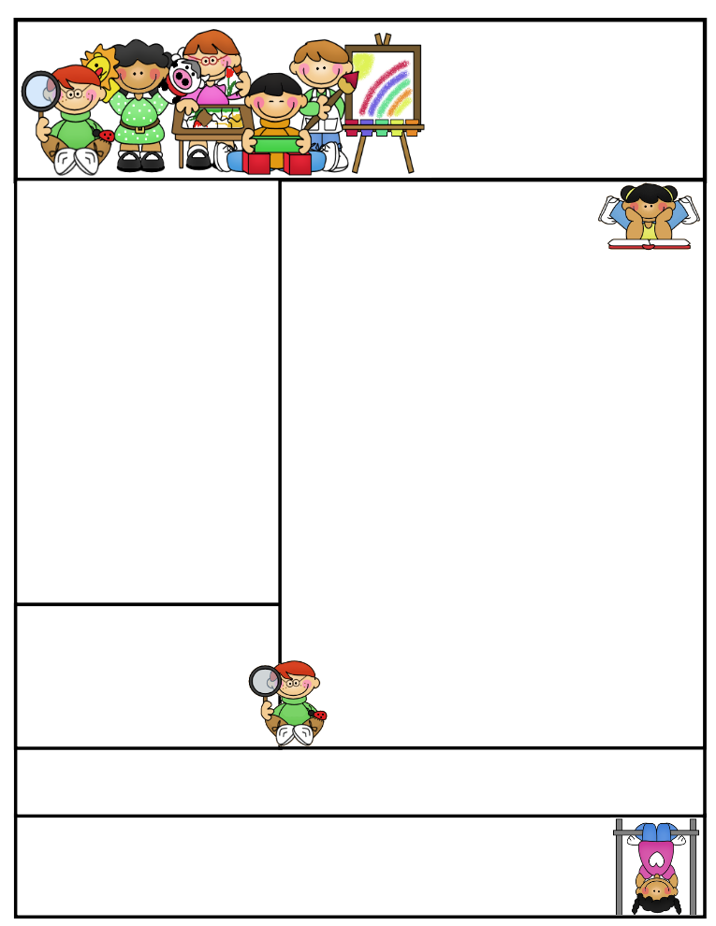

2nd grade Newsletter

April 27, 2015

[www.cherrycreek2ndgrade.weebly.com](http://www.cherrycreek2ndgrade.weebly.com)

**Literacy Tip:** Have your child verbally respond to you using complete sentences –this builds their oral language. If a child can respond in a complete sentence they can write a complete sentence. **Math Tip:** A site for printing your own addition math flashcard to practice every night- <http://www.apples4theteacher.com/math/addition/flashcards/>

**Spelling words**: Review

**High Frequency Words**: Review

**Leader in Me:**

**“We rise by lifting others.”**

**~ Robert Ingersoll**

**Important Dates**

**April 27- May 15—**Testing window. Make sure your child comes rested and has a good breakfast. We will have more specific dates for 2nd grade later.

**Friday April 17—**Croc Walk Carnival 6:30-8 p.m.

**Thursday April 22—**Leader in Me Parent Day. 1:00 p.m.

**Dance Festival—**Wednesday May 20 1:15 p.m.

What We’re Learning

This week we will continue to review all subjects before the end of year test. Testing will begin the first week of May. Due to the intense review of all subjects we will not be sending home spelling or homework this week. Please complete any review packets with your student this week in place of homework. Thanks!!

**Reading:** Review

**Math:** Review

**Writing:** We will continue to review opinion writing before the end of year test.

**Social Studies/Science:** We will be studying space and the night sky.

**Grammar:** Review

**Spelling:** Review

**Homework:** Read 20 minutes at least 5 days a week. **Record minutes on** [**www.rtsutah.com**](http://www.rtsutah.com)*Practice your spelling words every night.* Practice your math facts 5 minutes a night. *Fluency practice every night.* Complete the three ½ sheets*. All homework should be turned in on Friday*.

**Quote for the month:**

**“Nothing is IMPOSSIBLE,**

**The word itself says,**

**I’m possible!”**

**~Audrey Hepburn**