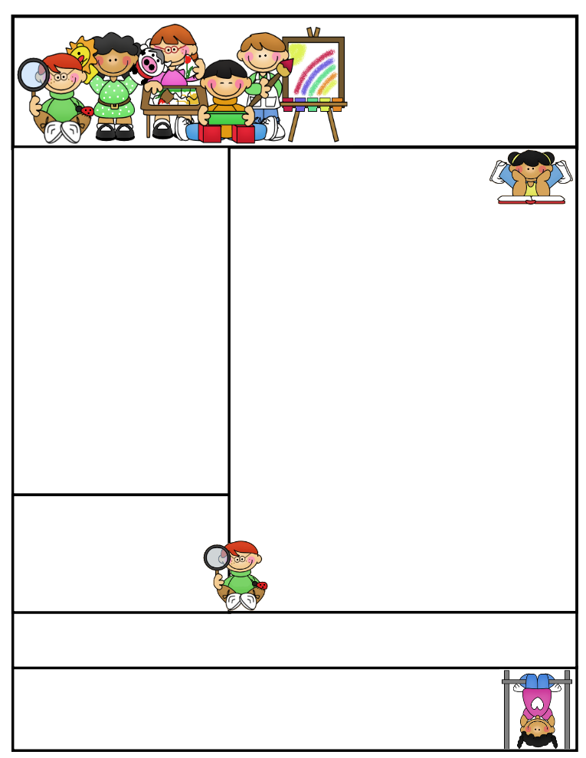

2nd grade Newsletter

December 1, 2014

www.cherrycreek2ndgrade.weebly.com

**Literacy Tip:** Have your child verbally respond to you using complete sentences –this builds their oral language. If a child can respond in a complete sentence they can write a complete sentence. **Math Tip:** A site for printing your own addition math flashcard to practice every night- <http://www.apples4theteacher.com/math/addition/flashcards/>

Spelling words: free, teach, teeth, please, beach, wheel, team, speak, sneeze, sheep, meaning weave REVIEW: eat, read CHALLENGE: between, reason

High Frequency Words: about, everything, story, two, first

**Leader in Me:**

I am the master of my destiny, the leader of my actions, the dictator of my world for the power lives in me and no one else. ~Christina Ow

**Important Dates**

* Our next **SEP’s** will be December 3, 2014
* **Christmas Around the World** field trip December 5, 2014
* **Christmas Break** December 19, 2014 – January 5, 2015

What We’re Learning

**Reading:** This week we’ll be reading informational text.

**Math:** We will continue to teach 2-digit addition with and without regrouping. If help is needed, please use the 2nd grade 2-digit/ 3-digit addition and subtraction strategies booklet.

**Writing:** We will continue our opinion writing unit.

**Social Studies:** We will be talking about comparing cultures.

**Grammar:** We will be learning about vowel diagraphs ee and ea.

**Spelling:** Words with ee and ea.

[**http://www.spellingcity.com/cherrycreek2ndgrade**](http://www.spellingcity.com/cherrycreek2ndgrade)

**Homework:** Read 20 minutes at least 5 days a week. **Record minutes on** [**www.rtsutah.com**](http://www.rtsutah.com)*Practice your spelling words every night.* Practice your math facts 5 minutes a night. *Fluency practice every night.* Complete the three ½ sheets*.*

*All homework should be turned in on Friday*.

1. **Quote for the month:**

Maybe Christmas doesn’t come from a store, maybe Christmas perhaps…means a little bit more… ~ The Grinch