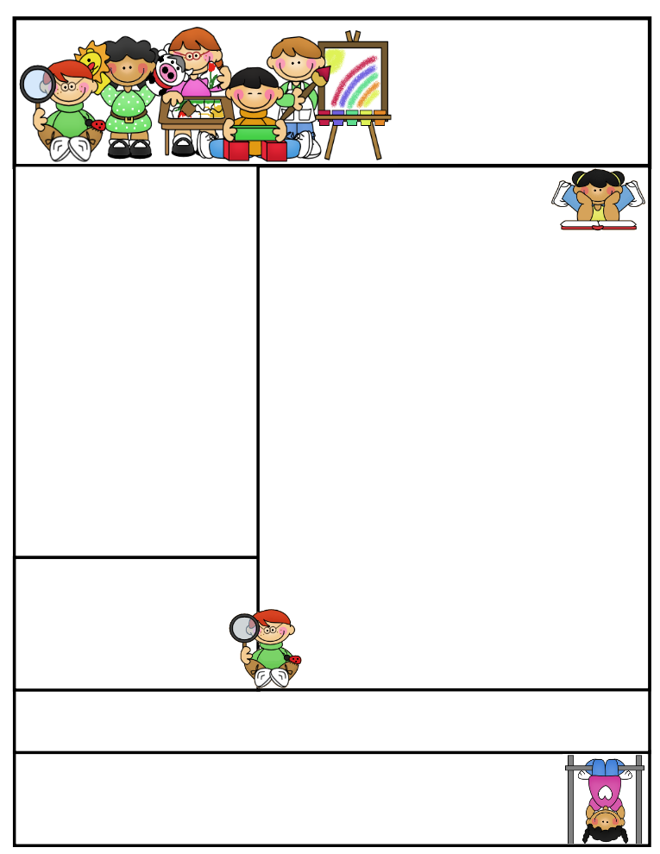

2nd grade Newsletter

December 15, 2014

www.cherrycreek2ndgrade.weebly.com

**Literacy Tip:** Have your child verbally respond to you using complete sentences –this builds their oral language. If a child can respond in a complete sentence they can write a complete sentence. **Math Tip:** A site for printing your own addition math flashcard to practice every night- <http://www.apples4theteacher.com/math/addition/flashcards/>

Spelling words: Christmas, reindeer, eggnog, Santa Claus, presents, lights, tree, nativity, sleigh bells, jingle, bow, elves, stocking, ornament, candy cane, jolly

High Frequency Words: none this week

**Leader in Me:**

Habit #7:

Sharpen the Saw

Take time to sharpen the saw over the break!

“A saw works better when it is sharp. A pencil works better when it is sharp. You work better when you are sharp.”

**Important Dates**

* **Christmas Break** December 19, 2014 – January 5, 2015

What We’re Learning

**Reading:** This week we’ll be reading Christmas stories. We will also be comparing and contrasting stories.

**Math:** We will be learning about money.

**Writing:** We will continue our opinion writing unit.

**Social Studies:** We will be talking about comparing cultures.

**Grammar:** We will be learning about commas in letters.

**Spelling:** Christmas words

[**http://www.spellingcity.com/cherrycreek2ndgrade**](http://www.spellingcity.com/cherrycreek2ndgrade)

**Homework:** Read 20 minutes at least 5 days a week. **Record minutes on** [**www.rtsutah.com**](http://www.rtsutah.com)*Practice your spelling words every night.* Practice your math facts 5 minutes a night. *Fluency practice every night.* Complete the three ½ sheets*.*

*All homework should be turned in on Friday*.

**Quote for the month:**

Maybe Christmas doesn’t come from a store, maybe Christmas perhaps…means a little bit more… ~ The Grinch