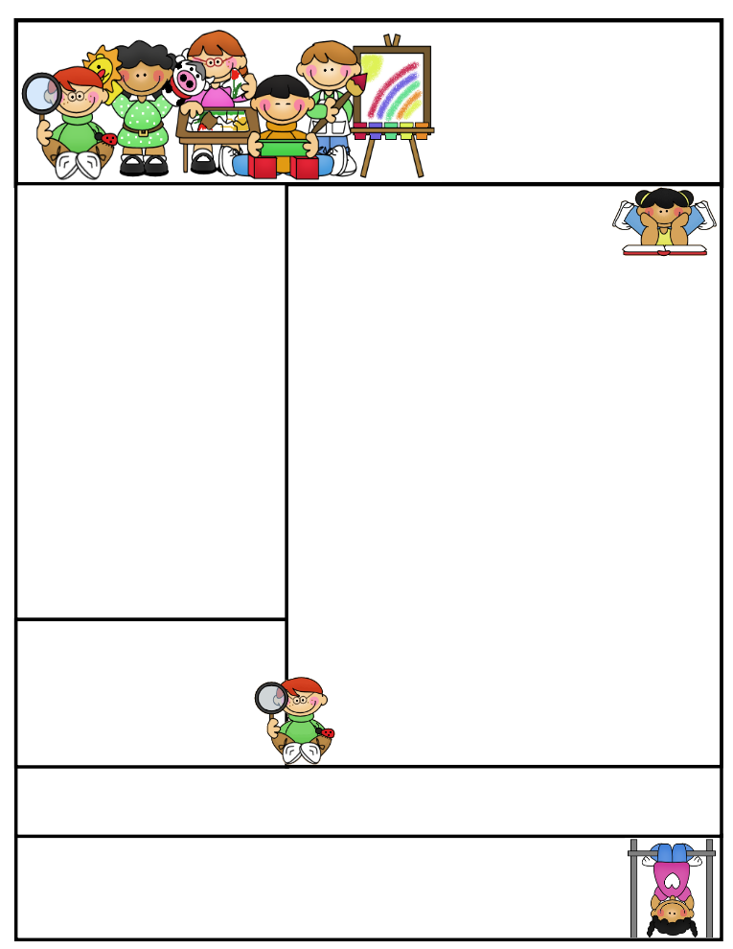

2nd grade Newsletter

December 8, 2014

www.cherrycreek2ndgrade.weebly.com

**Literacy Tip:** Have your child verbally respond to you using complete sentences –this builds their oral language. If a child can respond in a complete sentence they can write a complete sentence. **Math Tip:** A site for printing your own addition math flashcard to practice every night- <http://www.apples4theteacher.com/math/addition/flashcards/>

Spelling words: own, most, soap, float, both, know, loan, goat, flow, loaf, throw, coach, REVIEW: so, grow CHALLENGE: swallow, ocean

High Frequency Words: never, sky, stories, started, front

**Leader in Me:**

Habit #1:

Paradigms are not right or wrong, they are just different. Everyone has their own way of seeing things. Everyone has their own paradigm. Next time you don’t agree with someone, think of their paradigm too.

**Important Dates**

* **Christmas Break** December 19, 2014 – January 5, 2015

What We’re Learning

**Reading:** This week we’ll be reading informational text.

**Math:** We will be learning about money.

**Writing:** We will continue our opinion writing unit.

**Social Studies:** We will be talking about comparing cultures.

**Grammar:** We will be learning about reflexive pronouns.

**Spelling:** Words with long o( o, oa, ow).

[**http://www.spellingcity.com/cherrycreek2ndgrade**](http://www.spellingcity.com/cherrycreek2ndgrade)

**Homework:** Read 20 minutes at least 5 days a week. **Record minutes on** [**www.rtsutah.com**](http://www.rtsutah.com)*Practice your spelling words every night.* Practice your math facts 5 minutes a night. *Fluency practice every night.* Complete the three ½ sheets*.*

*All homework should be turned in on Friday*.

**Quote for the month:**

Maybe Christmas doesn’t come from a store, maybe Christmas perhaps…means a little bit more… ~ The Grinch