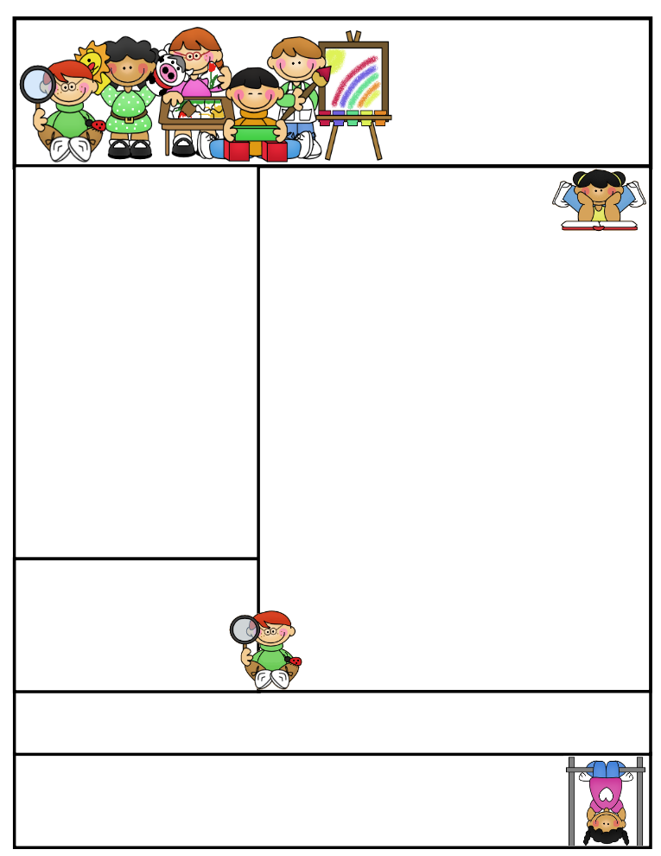

2nd grade Newsletter

February 16, 2015

[www.cherrycreek2ndgrade.weebly.com](http://www.cherrycreek2ndgrade.weebly.com)

**Literacy Tip:** Have your child verbally respond to you using complete sentences –this builds their oral language. If a child can respond in a complete sentence they can write a complete sentence. **Math Tip:** A site for printing your own addition math flashcard to practice every night- <http://www.apples4theteacher.com/math/addition/flashcards/>

**Spelling words**: father, over, under, herd, water, verb, paper, cracker, offer, cover, germ, master **Review:** fern, ever **Challenge:** remember, feather

**High Frequency Words**: nothing, behind, how, house, across

**Leader in Me:**

Habit #2

Begin With the End in Mind – Have a Plan

**Important Dates**

**February 18-** Box Tops Due – Final Day

What We’re Learning

**Reading:** We will be reading about animal life cycles, and analyzing and comparing nonfiction texts.

**Math:** We will be learning how to tell time.

**Writing:** We will be writing how to papers.

**Social Studies:** We will be talking about map features and where we are in the world, country, state, and city.

**Grammar:** We will be learning about adjectives.

**Spelling:** words with er.

[**http://www.spellingcity.com/cherrycreek2ndgrade**](http://www.spellingcity.com/cherrycreek2ndgrade)

**Homework:** Read 20 minutes at least 5 days a week. **Record minutes on** [**www.rtsutah.com**](http://www.rtsutah.com)*Practice your spelling words every night.* Practice your math facts 5 minutes a night. *Fluency practice every night.* Complete the three ½ sheets*.*

*All homework should be turned in on Friday*.

**Quote for the month:**

Have BIG dreams, you’ll grow into them.