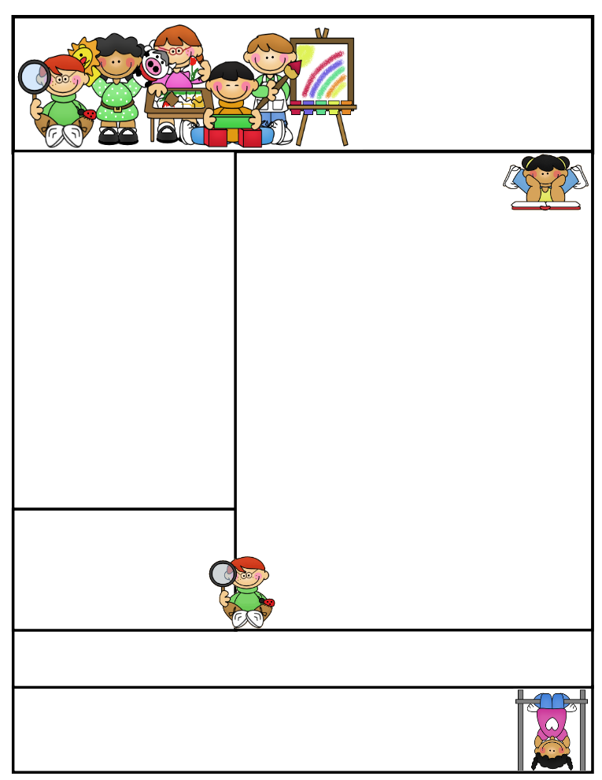

2nd grade Newsletter

February 9, 2015

[www.cherrycreek2ndgrade.weebly.com](http://www.cherrycreek2ndgrade.weebly.com)

**Literacy Tip:** Have your child verbally respond to you using complete sentences –this builds their oral language. If a child can respond in a complete sentence they can write a complete sentence. **Math Tip:** A site for printing your own addition math flashcard to practice every night- <http://www.apples4theteacher.com/math/addition/flashcards/>

Spelling words: night, kind, spy, child, light, find, right, high, wild, July, fry, sigh Review**:** by, why **Challenge:** behind, lightning

High Frequency Words: teacher, doing, any, sure, turned

**Leader in Me:**

Habit #2

Begin With the End in Mind – Have a Plan

**Important Dates**

**February 9-** Valentine box contest begins

**February 13-** Valentines Party

**February 14** Valentine’s Day

**February 16-** President’s day NO SCHOOL

What We’re Learning

**Reading:** We will be reading about how our heroes inspire us, analyzing, and comparing text and characters.

**Math:** We will be learning how to tell time.

**Writing:** We will be writing opinion papers.

**Social Studies:** We will be talking about map features and where we are in the world, country, state, and city.

**Grammar:** We will be learning about antonyms.

**Spelling:** words with long I spelled with i, igh, and y.

[**http://www.spellingcity.com/cherrycreek2ndgrade**](http://www.spellingcity.com/cherrycreek2ndgrade)

**Homework:** Read 20 minutes at least 5 days a week. **Record minutes on** [**www.rtsutah.com**](http://www.rtsutah.com)*Practice your spelling words every night.* Practice your math facts 5 minutes a night. *Fluency practice every night.* Complete the three ½ sheets*.*

*All homework should be turned in on Friday*.

**Quote for the month:**

*“The greatest leader is not necessarily the one who does the greatest things. He is the one that gets the people to do the greatest things.”*

*– Ronald Reagan*