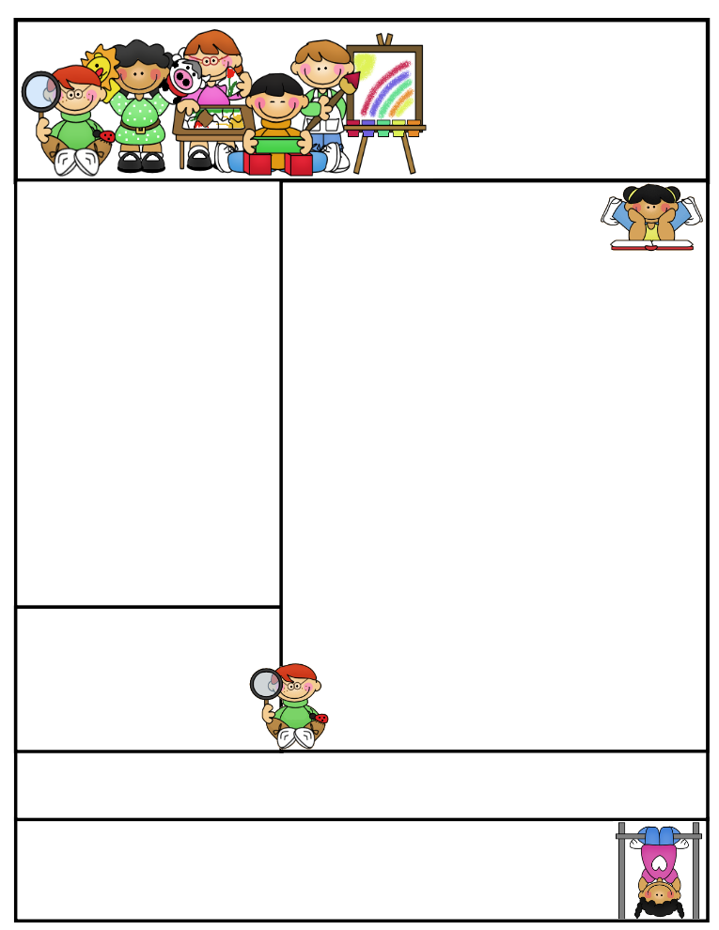

2nd grade Newsletter

January 12, 2015

www.cherrycreek2ndgrade.weebly.com

**Literacy Tip:** Have your child verbally respond to you using complete sentences –this builds their oral language. If a child can respond in a complete sentence they can write a complete sentence. **Math Tip:** A site for printing your own addition math flashcard to practice every night- <http://www.apples4theteacher.com/math/addition/flashcards/>

Spelling words: horn, story, fork, score, store, corn, morning, shore, short, born, tore, forget **Review:** for, more **Challenge:** report, force

High Frequency Words: said, something, saw, have, also

**Leader in Me:**

Habit #3

**Put First Things First**

*“The key is not to prioritize what’s on your schedule, but to schedule your priorities.” ~ Stephen Covey*

**Important Dates**

**January 16- No School (Teacher Development Day)**

**January 19- No School (Martin Luther King Day)**

What We’re Learning

**Reading:** We will be reading a fantasy story. We will be learning how to monitor and clarify.

**Math:** We will continue learning 2 digit subtraction.

**Writing:** We will be writing personal narratives.

**Social Studies:** We will be talking about citizenship and characteristics of a good citizen.

**Grammar:** We will be learning about conmmas in a series.

**Spelling:** words with –or and -ore

[**http://www.spellingcity.com/cherrycreek2ndgrade**](http://www.spellingcity.com/cherrycreek2ndgrade)

**Homework:** Read 20 minutes at least 5 days a week. **Record minutes on** [**www.rtsutah.com**](http://www.rtsutah.com)*Practice your spelling words every night.* Practice your math facts 5 minutes a night. *Fluency practice every night.* Complete the three ½ sheets*.*

*All homework should be turned in on Friday*.

**Quote for the month:**

“All of our DREAMS can come true, if we have the COURAGE to pursue them.”

Walt Disney