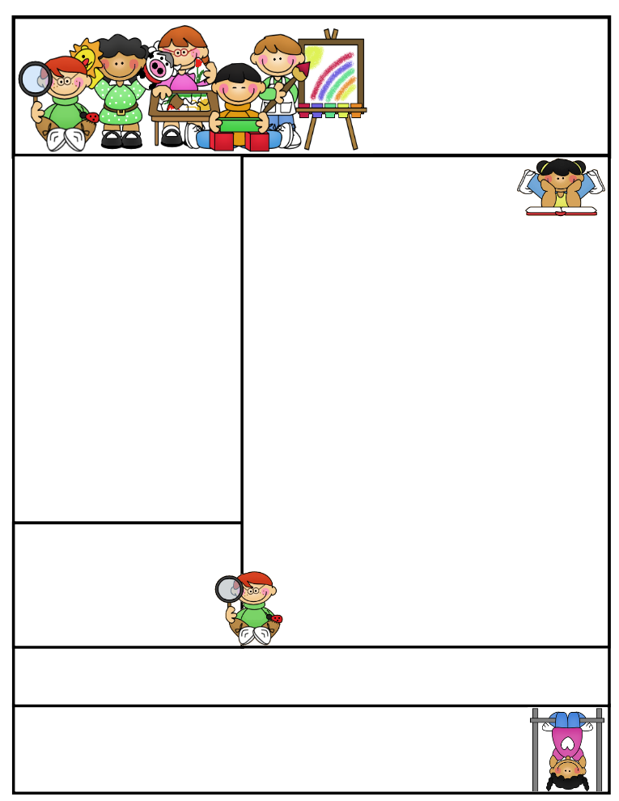

2nd grade Newsletter

January 20, 2015

www.cherrycreek2ndgrade.weebly.com

**Literacy Tip:** Have your child verbally respond to you using complete sentences –this builds their oral language. If a child can respond in a complete sentence they can write a complete sentence. **Math Tip:** A site for printing your own addition math flashcard to practice every night- <http://www.apples4theteacher.com/math/addition/flashcards/>

Spelling words: running, clapped, stopped, hopping, batted, selling, pinned, cutting, sitting, rubbed, missed, grabbed **Review:** mixed, going **Challenge:** wrapped, swelling

High Frequency Words: didn’t, I’ll, please, too, are

**Leader in Me:**

Habit #5

**Seek first to understand, then to be understood.**

“Understanding is a two-way street.” – Eleanor Roosevelt.

**Important Dates**

**January 19- No School (Martin Luther King Day)**

**January 20- Term 3 Begins Report cards sent home**

What We’re Learning

**Reading:** We will be reading a realistic fiction. We will be learning how to infer and predict.

**Math:** We will be working on addition and subtraction story problems.

**Writing:** We will be writing informational biographies.

**Social Studies:** We will be talking about contributions and value of different ethnic groups.

**Grammar:** We will be learning about homographs.

**Spelling:** words with –ed and –ing endings.

[**http://www.spellingcity.com/cherrycreek2ndgrade**](http://www.spellingcity.com/cherrycreek2ndgrade)

**Homework:** Read 20 minutes at least 5 days a week. **Record minutes on** [**www.rtsutah.com**](http://www.rtsutah.com)*Practice your spelling words every night.* Practice your math facts 5 minutes a night. *Fluency practice every night.* Complete the three ½ sheets*.*

*All homework should be turned in on Friday*.

**Quote for the month:**

“All of our DREAMS can come true, if we have the COURAGE to pursue them.”

Walt Disney