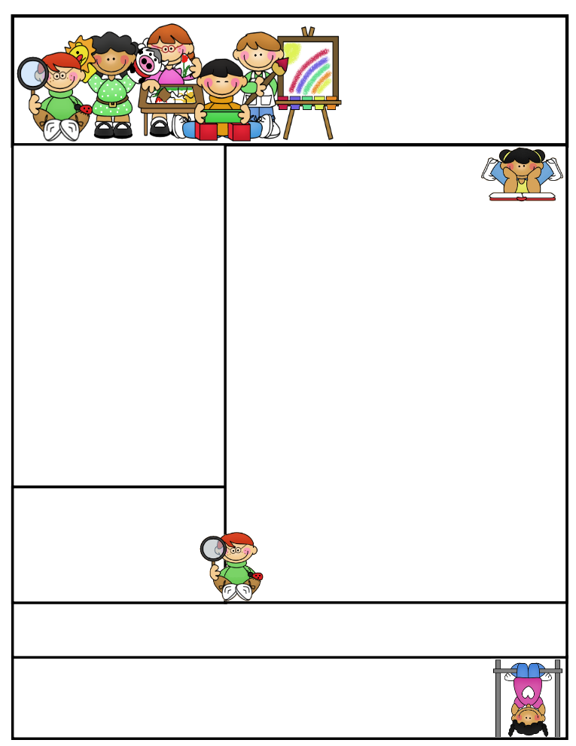

2nd grade Newsletter

January 5, 2015

www.cherrycreek2ndgrade.weebly.com

**Literacy Tip:** Have your child verbally respond to you using complete sentences –this builds their oral language. If a child can respond in a complete sentence they can write a complete sentence. **Math Tip:** A site for printing your own addition math flashcard to practice every night- <http://www.apples4theteacher.com/math/addition/flashcards/>

Spelling words: cannot, pancake, maybe, baseball, playground, someone, myself, classroom, sunshine, outside, upon, nothing, into, inside, nobody, everywhere

High Frequency Words: ever, thought, off, new, after

**Leader in Me:**

Habit #2:

**Begin With the End in Mind**

I plan ahead and set goals. I do things that have meaning and make a difference. I am an important part of my classroom and contribute to my school’s mission and vision. I look for ways to be a good citizen.

**Important Dates**

**January 16- No School (Teacher Development Day)**

**January 19- No School (Martin Luther King Day)**

What We’re Learning

**Reading:** We will be reading humorous fiction. We will be learning about cause and effect.

**Math:** We will be learning 2 digit subtraction.

**Writing:** We will be writing personal narratives.

**Social Studies:** We will be talking about health and safety.

**Grammar:** We will be learning about pronouns and reflexive pronouns.

**Spelling:** compound words

[**http://www.spellingcity.com/cherrycreek2ndgrade**](http://www.spellingcity.com/cherrycreek2ndgrade)

**Homework:** Read 20 minutes at least 5 days a week. **Record minutes on** [**www.rtsutah.com**](http://www.rtsutah.com)*Practice your spelling words every night.* Practice your math facts 5 minutes a night. *Fluency practice every night.* Complete the three ½ sheets*.*

*All homework should be turned in on Friday*.

**Quote for the month:**

“All of our DREAMS can come true, if we have the COURAGE to pursue them.”

Walt Disney