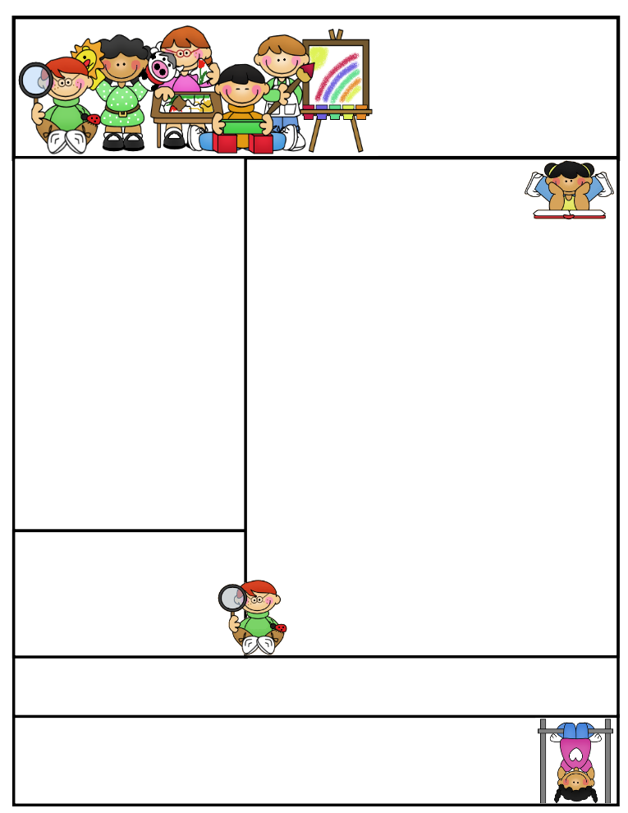

2nd grade Newsletter

March 2, 2015

[www.cherrycreek2ndgrade.weebly.com](http://www.cherrycreek2ndgrade.weebly.com)

**Literacy Tip:** Have your child verbally respond to you using complete sentences –this builds their oral language. If a child can respond in a complete sentence they can write a complete sentence. **Math Tip:** A site for printing your own addition math flashcard to practice every night- <http://www.apples4theteacher.com/math/addition/flashcards/>

**Spelling words**: meet, meat, week, weak, mane, main, tail, tale, be, bee, too, two **Review:** sea, see **Challenge:** threw, through

**High Frequency Words**: toward, what’s, does, their, found

**Leader in Me:**

Habit #4

Think Win-Win –

Everyone Can Win

**Important Dates**

**Monday March 2 – Friday March 6 –** Book Fair

**Wednesday March 4 –** SEP Conferences

**Wednesday March 4 –** Teeth Varnishing

**Sunday March 8 –** Daylight Saving Time Starts

**Tues-Thurs March 17-19 –** Kindergarten Registration

**Thursday March 19 –** Term 3 Ends

What We’re Learning

**Reading:** We will be reading about being friends and analyzing and comparing nonfiction texts.

**Math:** We will be continuing to learn how to add and subtract 3 digit numbers.

**Writing:** We will be writing fables.

**Social Studies:** We will be celebrating Dr. Seuss week.

**Grammar:** We will be learning about adjectives.

**Spelling:** homophones.

[**http://www.spellingcity.com/cherrycreek2ndgrade**](http://www.spellingcity.com/cherrycreek2ndgrade)

**Homework:** Read 20 minutes at least 5 days a week. **Record minutes on** [**www.rtsutah.com**](http://www.rtsutah.com)*Practice your spelling words every night.* Practice your math facts 5 minutes a night. *Fluency practice every night.* Complete the three ½ sheets*.*

*All homework should be turned in on Friday*.

**Quote for the month:**

Strong people don’t put others down… they lift them up.