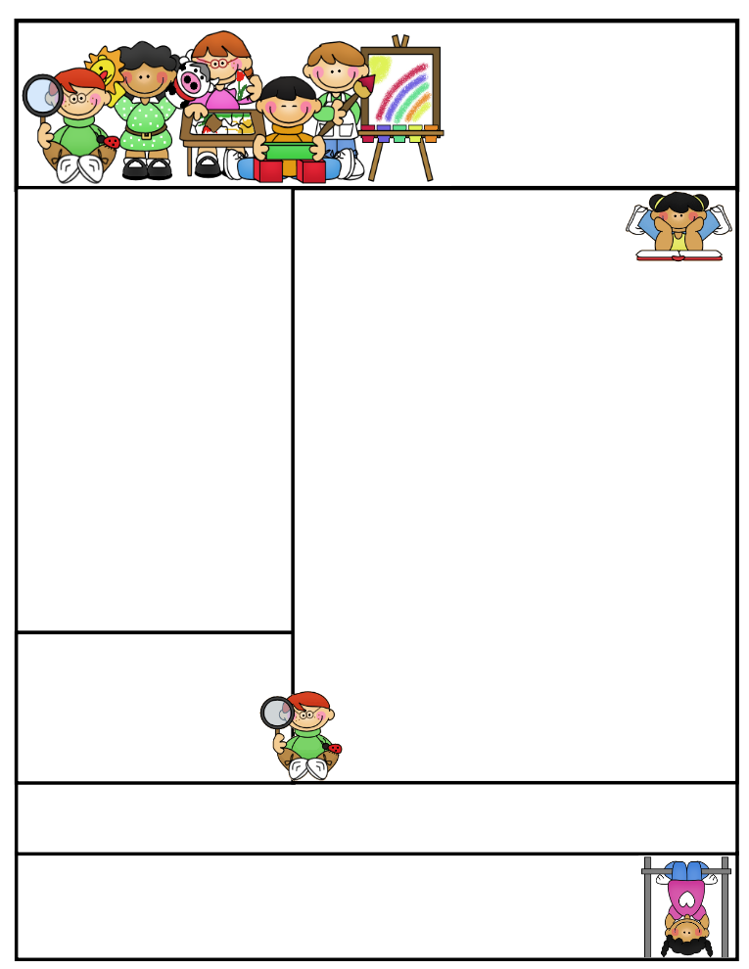

2nd grade Newsletter

March 23, 2015

[www.cherrycreek2ndgrade.weebly.com](http://www.cherrycreek2ndgrade.weebly.com)

**Literacy Tip:** Have your child verbally respond to you using complete sentences –this builds their oral language. If a child can respond in a complete sentence they can write a complete sentence. **Math Tip:** A site for printing your own addition math flashcard to practice every night- <http://www.apples4theteacher.com/math/addition/flashcards/>

**Spelling words**: root, crew, spoon, few, bloom, grew, room, you, stew, boost, scoop, flew **Review:** zoo, noon **Challenge:** shampoo, balloon

**High Frequency Words**: every, won’t, don’t, again, goes

**Leader in Me:**

Habit #6

Synergize –

Work together

**Important Dates**

**Safety Week March 23-27—**Mon. Crazy Socks, Tues. Pajama Day, Wed. Wear green and walk to school, Thur. Hat Day, Fri. Croc Walk

**Tuesday March 31 a.m.—**Second Grade Field Trip to Utah State Farm Field Day Harward Farms

**Tuesday March 31 1 p.m.—**Leadership Day for Community Leaders

**Spring Break—**April 6-10

What We’re Learning

**Reading:** We will be reading a fantacy story and understanding characteristics of fantacy.

**Math:** We will be learning about fractions.

**Writing:** We will continue learning about and writing poems.

**Social Studies/Science:** We will continue studying rocks.

**Grammar:** We will review contractions.

**Spelling:** ew, oo, ue, oul, ou

[**http://www.spellingcity.com/cherrycreek2ndgrade**](http://www.spellingcity.com/cherrycreek2ndgrade)

**Homework:** Read 20 minutes at least 5 days a week. **Record minutes on** [**www.rtsutah.com**](http://www.rtsutah.com)*Practice your spelling words every night.* Practice your math facts 5 minutes a night. *Fluency practice every night.* Complete the three ½ sheets*.*

*All homework should be turned in on Friday*.

**Quote for the month:**

Example isn’t another way to teach, it is the only way to teach. Albert Einstein