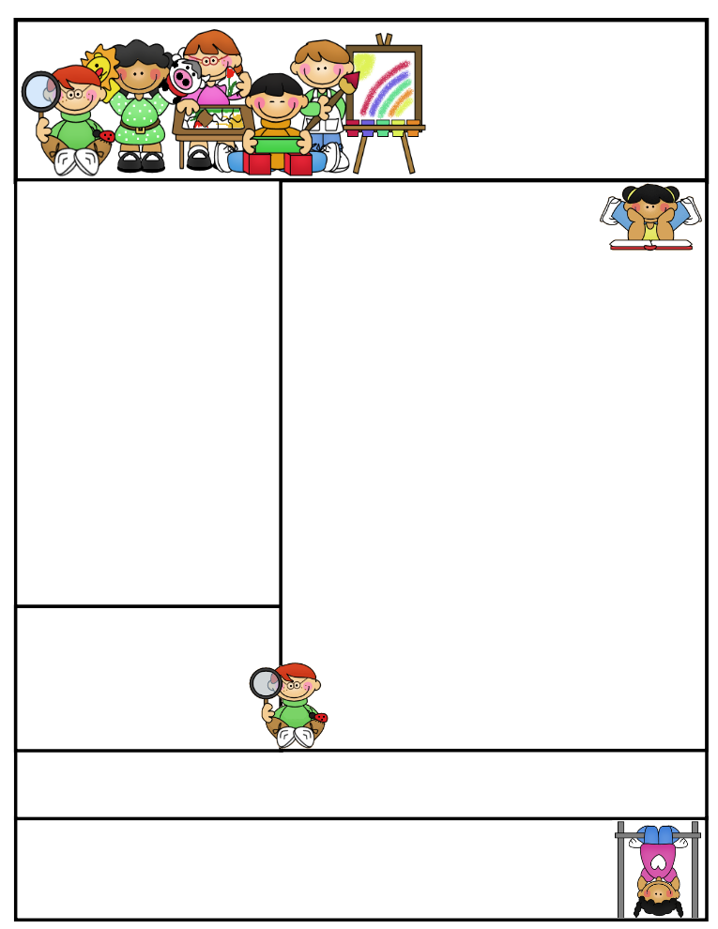

2nd grade Newsletter

March 30, 2015

[www.cherrycreek2ndgrade.weebly.com](http://www.cherrycreek2ndgrade.weebly.com)

**Literacy Tip:** Have your child verbally respond to you using complete sentences –this builds their oral language. If a child can respond in a complete sentence they can write a complete sentence. **Math Tip:** A site for printing your own addition math flashcard to practice every night- <http://www.apples4theteacher.com/math/addition/flashcards/>

**Spelling words**: aim, snail, bay, braid, ray, always, gain, sly, chain, shy, bright, fright **Review:** tray, try **Challenge:** contain, thigh

**High Frequency Words**: once, woman, your, near, who

**Leader in Me:**

Habit #7

Sharpen the Saw –

Enjoy Spring Break!

**Important Dates**

**Tuesday March 31 a.m.—**Second Grade Field Trip to Utah State Farm Field Day Harward Farms

**Tuesday March 31 1 p.m.—**Leadership Day for Community Leaders

**Spring Break—**April 6-10 NO SCHOOL

**Friday April 17—**Croc Walk Carnival 6:30-8 p.m.

What We’re Learning

**Reading:** We will be reading and discussing folktales and their characteristics.

**Math:** We will be learning about graphing and data.

**Writing:** We will review opinion writing before the end of year test.

**Social Studies/Science:** We will continue studying rocks.

**Grammar:** We will review possessive pronouns.

**Spelling:** Words with long a and i spelled ai, ay, igh, y.

[**http://www.spellingcity.com/cherrycreek2ndgrade**](http://www.spellingcity.com/cherrycreek2ndgrade)

**Homework:** Read 20 minutes at least 5 days a week. **Record minutes on** [**www.rtsutah.com**](http://www.rtsutah.com)*Practice your spelling words every night.* Practice your math facts 5 minutes a night. *Fluency practice every night.* Complete the three ½ sheets*.*

*All homework should be turned in on Friday*.

**Quote for the month:**

Example isn’t another way to teach, it is the only way to teach. Albert Einstein