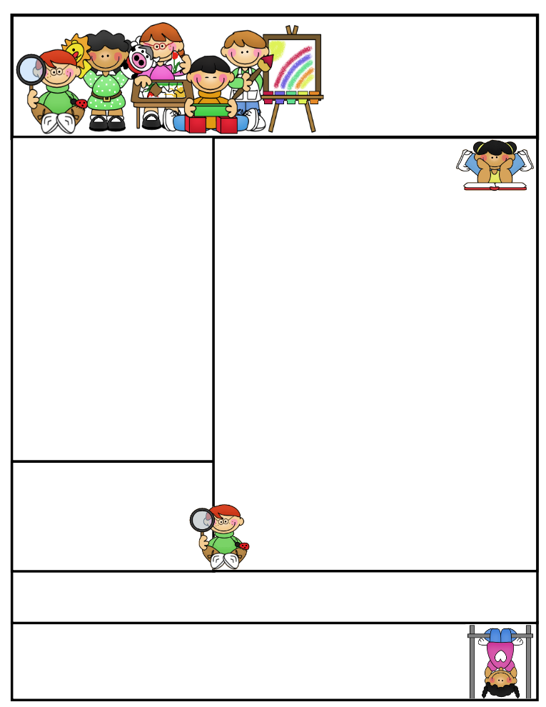

2nd grade Newsletter

March 9, 2015

[www.cherrycreek2ndgrade.weebly.com](http://www.cherrycreek2ndgrade.weebly.com)

**Literacy Tip:** Have your child verbally respond to you using complete sentences –this builds their oral language. If a child can respond in a complete sentence they can write a complete sentence. **Math Tip:** A site for printing your own addition math flashcard to practice every night- <http://www.apples4theteacher.com/math/addition/flashcards/>

**Spelling words**: unhappy, retell, untangle, unkind, repaint, refill, unlike, remake, unpack, reread, unlock, replay **Review:** rread, happy **Challenge:** rewrite, overheard

**High Frequency Words**: away, without, there, surprised, learning

**Leader in Me:**

Habit #4

Think Win-Win –

Everyone Can Win

**Important Dates**

**Tues-Thurs March 17-19 –** Kindergarten Registration

**Thursday March 19 –** Term 3 Ends

**Friday March 20—**No school

**Tuesday March 31 a.m.—**Second Grade Field Trip to Utah State Farm Field Day Harward Farms

**Tuesday March 31 1 p.m.—**Leadership Day for Community Leaders

What We’re Learning

**Reading:** We will be reading fables and understanding what makes a fable.

**Math:** We will be continuing to learn how to add and subtract 3 digit numbers.

**Writing:** We will be writing fables.

**Social Studies:** We will be studying plants.

**Grammar:** We will be learning irregular action verbs.

**Spelling:** prefixes un- and re-.

[**http://www.spellingcity.com/cherrycreek2ndgrade**](http://www.spellingcity.com/cherrycreek2ndgrade)

**Homework:** Read 20 minutes at least 5 days a week. **Record minutes on** [**www.rtsutah.com**](http://www.rtsutah.com)*Practice your spelling words every night.* Practice your math facts 5 minutes a night. *Fluency practice every night.* Complete the three ½ sheets*.*

*All homework should be turned in on Friday*.

**Quote for the month:**

Example isn’t another way to teach, it is the only way to teach. Albert Einstein