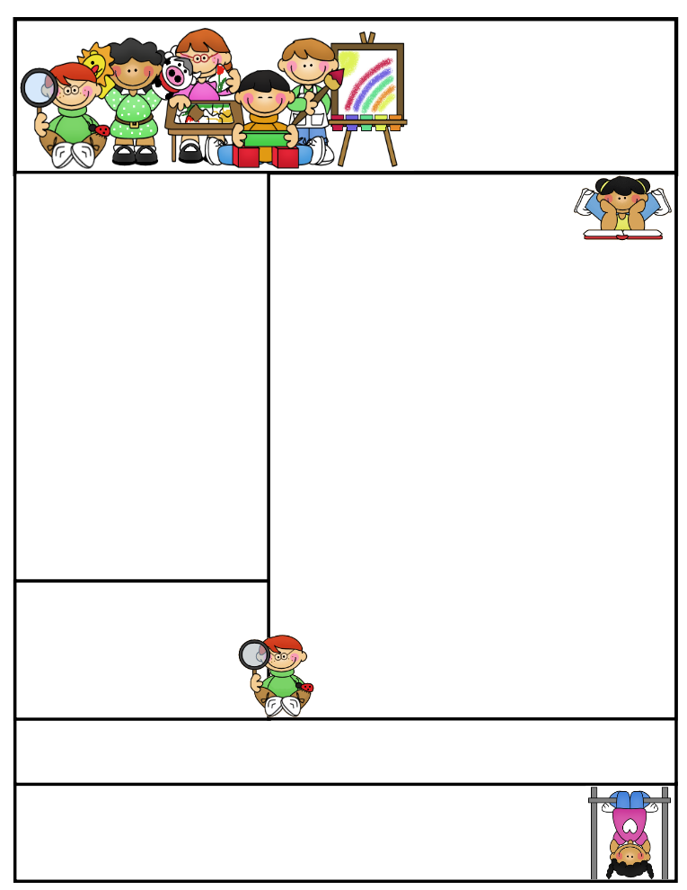

2nd grade Newsletter

May 11th 2015

[www.cherrycreek2ndgrade.weebly.com](http://www.cherrycreek2ndgrade.weebly.com)

**Literacy Tip:** Have your child verbally respond to you using complete sentences –this builds their oral language. If a child can respond in a complete sentence they can write a complete sentence. **Math Tip:** A site for printing your own addition math flashcard to practice every night- <http://www.apples4theteacher.com/math/addition/flashcards/>

**Spelling words**: seated, keeps, speed, seen, means, clean, groan, roast, bowls, crow, owe, grown, green, snow, peace, below

**High Frequency Words**: together, remember, dear, almost, sometimes

**Leader in Me:**

**“We rise by lifting others.”**

**~ Robert Ingersoll**

**Important Dates**

**May 11- May 15—**Testing make up week for those that were absent. Writing test for all 2nd grade students on Monday, May 11th.

**Dance Festival—**Wednesday, May 20 1:15 p.m.

**Memorial Day­­—**May 25th

**Field Day­—** Thursday, May 28th

**Last Day of School­—**May 29th

What We’re Learning

Most of our testing is complete!! Your students have been amazing! Great job 2nd graders!!!!

**Reading:** We will be reading a social studies story about Benjamin Franklin

**Math:** Fast facts and review subjects where extra emphasis is needed.

**Writing:** We will continue to review opinion writing before the end of year test.

**Social Studies/Science:** Science and the scientific process

**Grammar:** Review subjects where extra emphasis is needed.

**Spelling:** ou,ow,ee, ea –long vowel words.

**Homework:** Read 20 minutes at least 5 days a week. **Record minutes on** [**www.rtsutah.com**](http://www.rtsutah.com)*Practice your spelling words every night.* Practice your math facts 5 minutes a night. *Fluency practice every night.* Complete the three ½ sheets*. All homework should be turned in on Friday*.

**Quote for the month:**

**“Nothing is IMPOSSIBLE,**

**The word itself says,**

**I’m possible!”**

**~Audrey Hepburn**