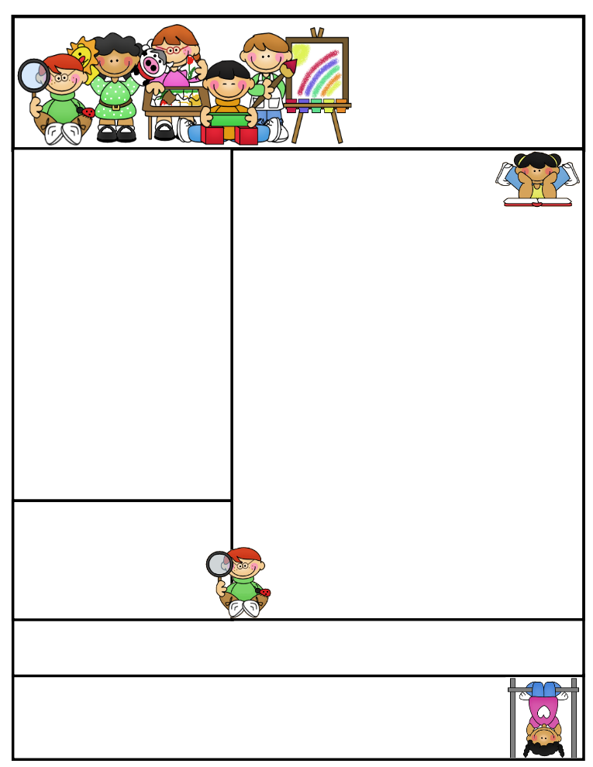

2nd grade Newsletter

May, 4th 2015

[www.cherrycreek2ndgrade.weebly.com](http://www.cherrycreek2ndgrade.weebly.com)

**Literacy Tip:** Have your child verbally respond to you using complete sentences –this builds their oral language. If a child can respond in a complete sentence they can write a complete sentence. **Math Tip:** A site for printing your own addition math flashcard to practice every night- <http://www.apples4theteacher.com/math/addition/flashcards/>

**Spelling words**: Review

**High Frequency Words**: Review

**Leader in Me:**

**“We rise by lifting others.”**

**~ Robert Ingersoll**

**Important Dates**

**May 4- May 15—**Testing window. Make sure your child comes rested and has a good breakfast. .

**BYU field Trip—**Tuesday, May 5th at 9:00 a.m.

**Dance Festival—**Wednesday, May 20 1:15 p.m.

**Memorial Day­­—**May 25th

**Last Day of School­—**May 29th

What We’re Learning

**It’s testing week!!!** Please make sure that your students are at school on time, that they are well rested, and have had plenty to eat before coming to school this week. We will be testing each morning except for Tuesday, May 5th –due to our 2nd grade field trip to BYU. Testing in our classroom will finish up on Monday, May 11th. We will continue to review when we aren’t testing. We will continue to send review packets home next week. Please review those subjects that your student might need help with, thanks!!

**Reading:** Review

**Math:** Review

**Writing:** We will continue to review opinion writing before the end of year test.

**Grammar:** Review

**Spelling:** Review

**Homework: Review packets. Read** 20 minutes at least 5 days a week. We will be sending home the **fluency sheets** with the newsletter this week. Please practice **fast facts.**

**Quote for the month:**

**“Nothing is IMPOSSIBLE,**

**The word itself says,**

**I’m possible!”**

**~Audrey Hepburn**