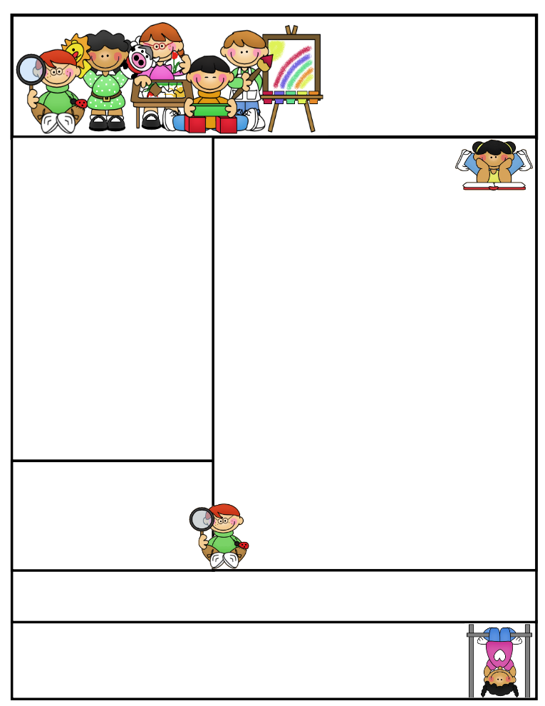

2nd grade Newsletter

November 10, 2014

www.cherrycreek2ndgrade.weebly.com

**Literacy Tip:** Practice reading out loud using expression.

**Math Tip:** A site for printing your own addition math flashcard to practice every night- <http://www.apples4theteacher.com/math/addition/flashcards/>

Spelling words: hens, eggs, ducks, bikes, boxes, wishes, dresses, names, bells, stamps, dishes, grapes REVIEW: jets, frogs CHALLENGE: stitches, fences

High Frequency Words: some, kind, light, more, far

**Leader in Me:**

Habit 6:

“Synergy is the highest activity in all life—the true test and manifestation of all the other habits put together.” Stephen R. Covey

**Important Dates**

* Please send empty toilet paper rolls with your children. They will be used for a Thanksgiving project.
* Friday November 21 – Thanksgiving Point field trip.
* Our next SEP’s will be December 3, 2014.

What We’re Learning

**Reading:** This week we’ll be reading humorous fiction.

**Math:** We will begin our unit on greater than and less than.

**Writing:** We will continue our opinion writing unit.

**Science:** We will be talking about gravity.

**Grammar:** We will be learning about prefixes.

**Spelling:** Base words with endings.

[**http://www.spellingcity.com/cherrycreek2ndgrade**](http://www.spellingcity.com/cherrycreek2ndgrade)

**Homework:** Read 20 minutes at least 5 days a week. **Record minutes on** [**www.rtsutah.com**](http://www.rtsutah.com)*Practice your spelling words every night.* Practice your math facts 5 minutes a night. *Fluency practice every night.* Complete the three ½ sheets*.*

*All homework should be turned in on Friday*.

Quote for the month:

A thankful heart is not only the greatest virtue, but the parent of all other virtues.

~ Cicero