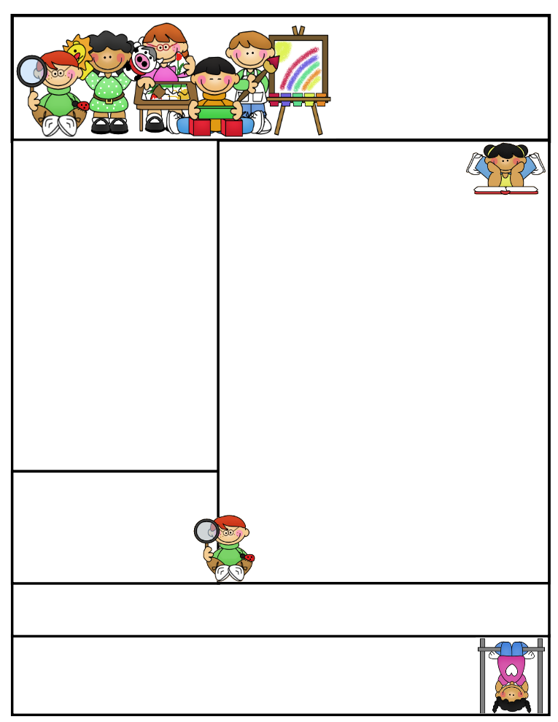

2nd grade Newsletter

November 17, 2014

www.cherrycreek2ndgrade.weebly.com

**Literacy Tip:** Practice reading out loud using expression.

**Math Tip:** A site for printing your own addition math flashcard to practice every night- <http://www.apples4theteacher.com/math/addition/flashcards/>

Spelling words: pay, wait, paint, train, pail, clay, tray, plain, stain, hay, gray, away REVIEW: stay, day CHALLENGE: raisin, birthday

High Frequency Words: someone, night, against, different, morning

**Announcements:**

All of you will be receiving newsletters with something printed on the back. We’ve had a lot of resources for math to choose from this year, and we haven’t used them all. Mrs. Hardman, Mrs. Chang and Ms. Baldwin will send home newsletters, of different colors, with math printed on the other side. Please discard the math side. Your student is welcome to use it if they’d like, but it isn’t an assignment. Thanks!

**Important Dates**

* Please send empty toilet paper rolls with your children. They will be used for a Thanksgiving project.
* Friday November 21 – Thanksgiving Point field trip.
* Our next SEP’s will be December 3, 2014.

**What We’re Learning**

**Reading:** This week we’ll be reading realistic fiction.

**Math:** We will begin our unit on 2-digit addition.

**Writing:** We will continue our opinion writing unit.

**Social Studies:** We will be talking about American Indians.

**Grammar/Spelling:** We will be taking a closer look at words with ai and ay.

**<http://www.spellingcity.com/cherrycreek2ndgrade>**

**Homework:** Read 20 minutes at least 5 days a week. **Record minutes on** [**www.rtsutah.com**](http://www.rtsutah.com)*Practice your spelling words every night.* Practice your math facts 5 minutes a night. *Fluency practice every night.* Complete the three ½ sheets*.*

*All homework should be turned in on Friday*.

Quote for the month:

A thankful heart is not only the greatest virtue, but the parent of all other virtues.

~ Cicero