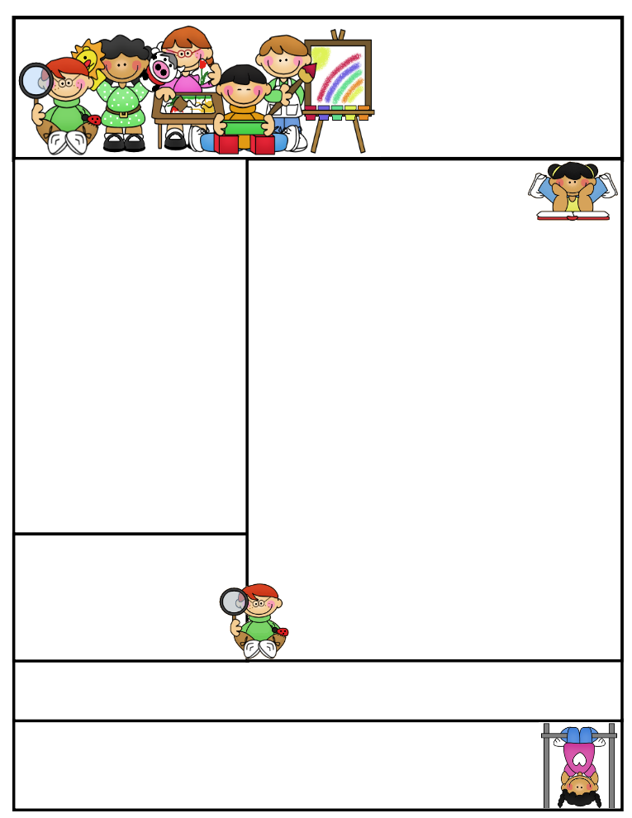

2nd grade Newsletter

November 24, 2014

www.cherrycreek2ndgrade.weebly.com

**Literacy Tip:** Have your child verbally respond to you using complete sentences –This builds their oral language. If a child can respond in a complete sentence they can write a complete sentence. **Math Tip:** A site for printing your own addition math flashcard to practice every night- <http://www.apples4theteacher.com/math/addition/flashcards/>

Spelling words: No Spelling this week!

High Frequency Words: No word wall words this week!

**Leader in Me:**

**Habit #1: Choose your own weather** Count your rainbows, not your thunderstorms. ~Alyssa Knight (age 12)

**Important Dates**

* Thanksgiving break November 26th -28th
* Our next SEP’s will be December 3, 2014.
* Parents, if you’d like to share a culture, or tradition, during the month of December…please contact your teacher.

What We’re Learning

**Reading:** We will be reading Thanksgiving stories.

**Math:** We will continue to teach 2-digit addition with and without regrouping

**Writing:** We will continue our opinion writing unit.

**Social Studies:** We will learning about American Indians.

**Grammar:** We will revisit concepts using fun our fun Thanksgiving theme.

**Spelling:** No spelling this week!

[**http://www.spellingcity.com/cherrycreek2ndgrade**](http://www.spellingcity.com/cherrycreek2ndgrade)

**Homework:** Read 20 minutes at least 5 days a week. **Record minutes on** [**www.rtsutah.com**](http://www.rtsutah.com)*Practice your spelling words every night.* Practice your math facts 5 minutes a night. *Fluency practice every night.* Complete the three ½ sheets*.*

*All homework should be turned in on Fridays*.

Quote for the month:

A thankful heart is not only the greatest virtue, but the parent of all other virtues.

~ Cicero