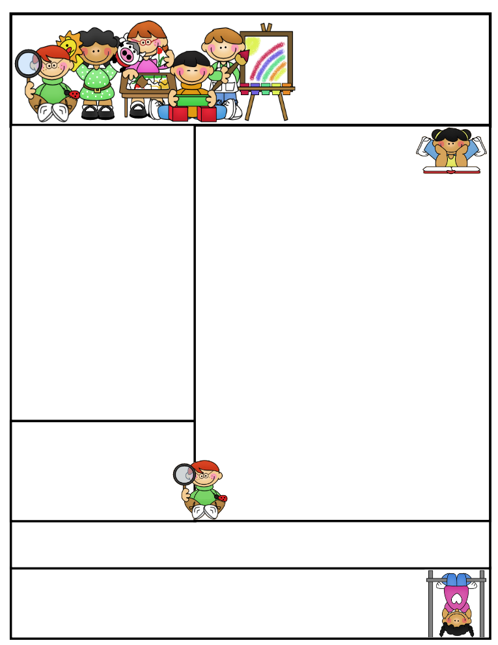

2nd grade Newsletter

November 3, 2014

www.cherrycreek2ndgrade.weebly.com

Thanks for everyone’s help with our Halloween celebrations. We appreciate all you do for your children!

**Important Dates**

* Please send empty toilet paper rolls with your children. They will be used for a Thanksgiving project.
* Friday November 21 – Thanksgiving Point field trip.
* Our next SEP’s will be December 3, 2014.

What We’re Learning

**Reading:** Focus on reading informational text.

**Math:** This week we will learning about place value and understanding both place and value.

**Writing:** This week we will begin opinion writing.

**Science:** We will be talking about matter.

**Grammar:** We will be learning about contractions.

**Spelling:** Contractions.

[**http://www.spellingcity.com/cherrycreek2ndgrade**](http://www.spellingcity.com/cherrycreek2ndgrade)

**Homework:** Read 20 minutes at least 5 days a week. **Record minutes on** [**www.rtsutah.com**](http://www.rtsutah.com)*Practice your spelling words every night.* Practice your math facts 5 minutes a night. *Fluency practice every night.* Complete the three ½ sheets*.*

*All homework should be turned in on Friday*.

**Literacy Tip:** Practice reading out loud and being accurate.

**Math Tip:** A site for printing your own addition math flashcard to practice every night- <http://www.apples4theteacher.com/math/addition/flashcards/>

Spelling words: I’m don’t, isn’t, can’t, we’ll, it’s, I’ve, didn’t, you’re, that’s, wasn’t, you’ve REVIEW: us, them CHALLENGE: they’re, wouldn’t

High Frequency Words: because, right, they, was, really

Quote for the month:

“Education is the key to unlock the golden door of freedom.”

George Washington Carver