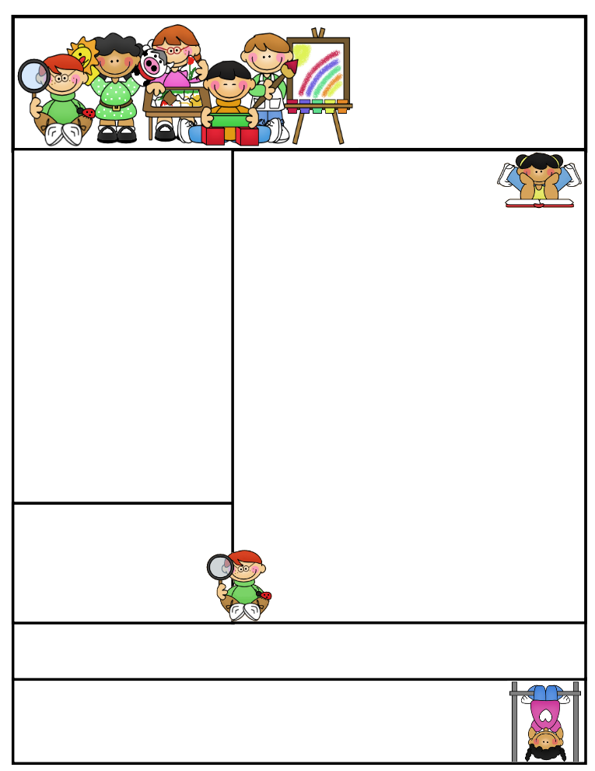

2nd grade Newsletter

October 13, 2014

Thank you for your attendance at SEP’s. It was fun to meet with you and celebrate your children!

**Important Dates**

* Tuesday October 14 -- Walking field trip to Reams from 1 to 2:30 p.m. to learn about where our food comes from.
* Fall Break October 16-17.
* Friday November 21 – Thanksgiving Point field trip.

What We’re Learning

**Reading:** We will be doing activities on bats and Columbus.

**Math:** This week we are focusing on even and odd numbers.

**Writing:** This week we are sharing our animal reports, doing some Columbus activiities, and some fall writing.

**Science:** We will be learning about bats.

**Grammar:** We’re going to review phonics long a and long e.

**Spelling:** No spelling this week.

[**http://www.spellingcity.com/cherrycreek2ndgrade**](http://www.spellingcity.com/cherrycreek2ndgrade)

**Homework:** Read 20 minutes at least 5 days a week. **Record minutes on** [**www.rtsutah.com**](http://www.rtsutah.com)*Practice your spelling words every night.* Practice your math facts 5 minutes a night. Watch for flashcards to come home for math practice.

**Literacy Tip:** Practice reading out loud and being accurate.

**Math Tip:** A site for printing your own addition math flashcard to practice every night- <http://www.apples4theteacher.com/math/addition/flashcards/>

Spelling words: None this week.

High Frequency Words: None this week.

Quote for the month:

“Let us tenderly and kindly cherish therefore, the means of knowledge. Let us dare to read, think, speak, and write.” --John Adams