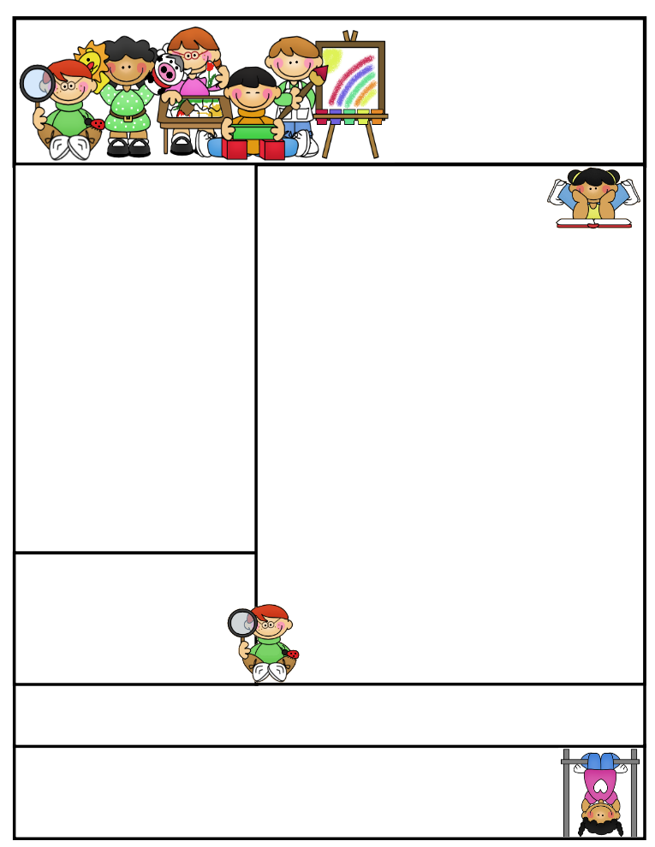

2nd grade Newsletter

October 27, 2014

www.cherrycreek2ndgrade.weebly.com

We love teaching your children and we appreciate all the help we get from you! It is a team effort.

**Important Dates**

* October 27-31 Red Ribbon Week. See flyer for information.
* Friday October 31, 2014 Halloween Parade 12:50 p.m.
* Friday November 21 – Thanksgiving Point field trip.

What We’re Learning

**Reading:** Focus on reading realistic fiction.

**Math:** This week we will finish skip counting and patterns on a hundreds chart and begin place value.

**Writing:** This week we will begin opinion writing.

**Science:** We will continue talking about weather.

**Grammar:** We will be learning about common and proper nouns.

**Spelling:** Words ending with double consonants and –ck.

[**http://www.spellingcity.com/cherrycreek2ndgrade**](http://www.spellingcity.com/cherrycreek2ndgrade)

**Homework:** Read 20 minutes at least 5 days a week. **Record minutes on** [**www.rtsutah.com**](http://www.rtsutah.com)*Practice your spelling words every night.* Practice your math facts 5 minutes a night. *Fluency practice every night.* Complete the three ½ sheets*.*

*All homework should be turned in on Friday*.

**Literacy Tip:** Practice reading out loud and being accurate.

**Math Tip:** A site for printing your own addition math flashcard to practice every night- <http://www.apples4theteacher.com/math/addition/flashcards/>

Spelling words: dress, spell, class, full, add, neck, stuck, kick, rock, black, trick, doll, REVIEW: will, off CHALLENGE: across, pocket

High Frequency Words: funny, try, cried, air, pictures

Quote for the month:

“Let us tenderly and kindly cherish therefore, the means of knowledge. Let us dare to read, think, speak, and write.” --John Adams