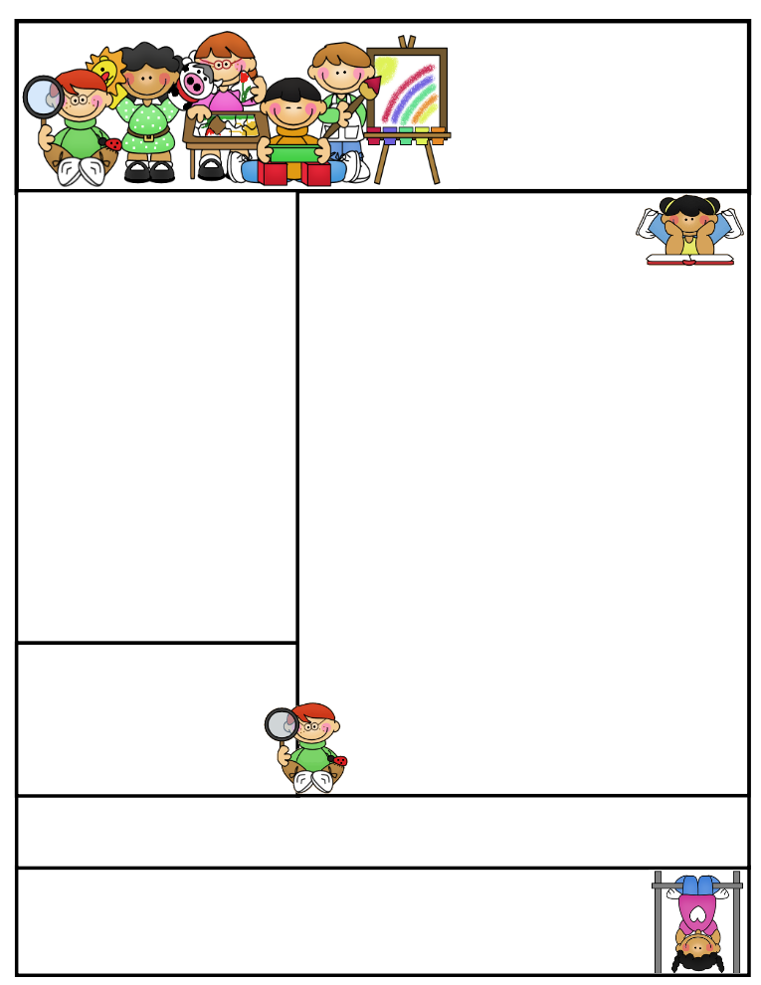

2nd grade Newsletter

October 20, 2014

www.cherrycreek2ndgrade.weebly.com

We love teaching your children and we appreciate all the help we get from you! It is a team effort. Thanks for helping us with the Reams field trip.

**Important Dates**

* Friday October 24, 2014 no school. Teachers will be receiving more Leader in Me training.
* Friday October 31, 2014 Halloween Parade 12:45 p.m.
* Friday November 21 – Thanksgiving Point field trip.

What We’re Learning

**Reading:** Focus on reading informational text.

**Math:** This week we are focusing on skip counting and patterns on a hundreds chart.

**Writing:** This week we are talking about and writing poetry.

**Science:** We will be talking about weather.

**Grammar:** We will be learning about compound words.

**Spelling:** Words with consonant digraphs th, sh, wh, ch, tch, ph.

[**http://www.spellingcity.com/cherrycreek2ndgrade**](http://www.spellingcity.com/cherrycreek2ndgrade)

**Homework:** Read 20 minutes at least 5 days a week. **Record minutes on** [**www.rtsutah.com**](http://www.rtsutah.com)*Practice your spelling words every night.* Practice your math facts 5 minutes a night. *Fluency practice every night.* Complete the three ½ sheets*.*

*All homework should be turned in on Friday*.

**Literacy Tip:** Practice reading out loud and being accurate.

**Math Tip:** A site for printing your own addition math flashcard to practice every night- <http://www.apples4theteacher.com/math/addition/flashcards/>

Spelling words: dish, than, chest, such, thin, push, shine, chase, white, while, these, flash REVIEW: which, then CHALLENGE: catch, thumb

High Frequency Words: people, my, before, starts, few

Quote for the month:

“Let us tenderly and kindly cherish therefore, the means of knowledge. Let us dare to read, think, speak, and write.” --John Adams