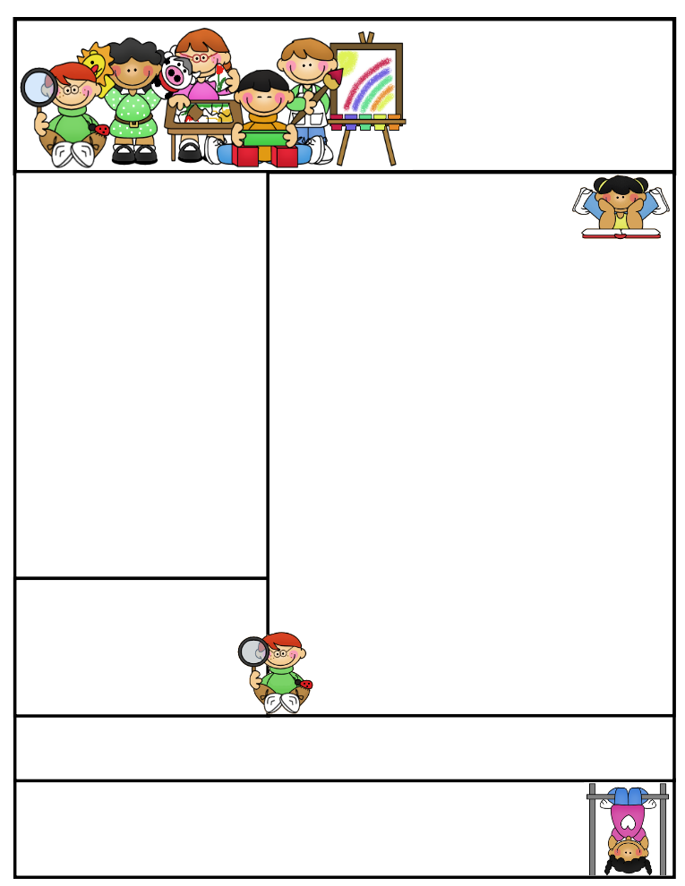

2nd grade Newsletter

October 6, 2014

Thanks for helping us with the library field trip. We really enjoy your children. We look forward to meeting with you this week!

**Important Dates**

* Wednesday October 8 – SEP Conferences. Don’t forget your appointment!
* Tuesday October 14 -- Possible walking field trip to Reams (watch for permission note).
* Friday November 21 – Thanksgiving Point field trip.

What We’re Learning

**Reading:** Focus on Fables.

**Math:** This week we are focusing on missing addends.

**Writing:** This week we are continuing to write our animal reports.

**Science:** We will be finishing and sharing our animal reports.

**Grammar:** We will be learning about verbs.

**Spelling:** Base words and endings –ed, -ing.

[**http://www.spellingcity.com/cherrycreek2ndgrade**](http://www.spellingcity.com/cherrycreek2ndgrade)

**Homework:** Read 20 minutes at least 5 days a week. **Record minutes on** [**www.rtsutah.com**](http://www.rtsutah.com)*Practice your spelling words every night.* Practice your math facts 5 minutes a night. *Fluency practice every night.* Complete the three ½ sheets*.*

*All homework should be turned in on Friday*.

**Literacy Tip:** Practice reading out loud and being accurate.

**Math Tip:** A site for printing your own addition math flashcard to practice every night- <http://www.apples4theteacher.com/math/addition/flashcards/>

Spelling words: liked, using, riding, chased, spilled, making, closed, hoping, baked, hiding, standing, asked REVIEW: mixed, sleeping CHALLENGE: teasing, knocking

High Frequency Words: would, might, why, many, for

Quote for the month:

“Let us tenderly and kindly cherish therefore, the means of knowledge. Let us dare to read, think, speak, and write.” --John Adams